LAB-04 TASKS

Task-01:
import java.util.Scanner;
class Box {
public int width;
public int height;
void print(){
System.out.println("Width: " + width);
System.out.println("Height: " + height);
}
//Constructors:
public Box(int width, int height){
if(width > 0 && height > 0){
this.width = width;
this.height = height;
}
}
public Box(int height){
Scanner sc = new Scanner(System.in);
System.out.println("Enter width: ");
this.width = sc.nextInt();
this.height = height;
}
public Box(){
Scanner sc = new Scanner(System.in);
System.out.println("Enter width: ");
this.width = sc.nextInt();
System.out.println("Enter height: ");
this.height = sc.nextInt();
}
}
class task1 {
public static void main(String[] args){
Box b1 = new Box(10, 15);
b1.print();
Box b2 = new Box(15);
b2.print();
Box b3 = new Box();
b3.print();
}
}
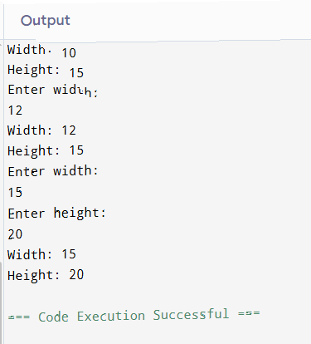

Task-02:
class Book {
private String title;
private String author;
private double price;
//Constructor
public Book(String title, String author, double price){
this.title = title;
this.author = author;
this.price = price;
}
//Setter (to update)
public void setTitle(String title){
if(title != null && !title.trim().isEmpty()){
this.title = title;
}
else{
System.out.println("Title cannot be empty!");
}
}
public void setAuthor(String author){
if(author != null && !author.trim().isEmpty()){
this.author = author;
}
else{
System.out.println("Author cannot be empty!");
}
}
public void setPrice(double price){
if(price > 0){
this.price = price;
}
else{
this.price = 0.0;
System.out.println("Price cannot be negative. Set to 0.0");
}
}
//Getter (to retrieve)
public String getTitle(){ return title; }
public String getAuthor(){ return author; }
public double getPrice(){ return price; }
}
class task2 {
public static void main(String[] args){
Book b1 = new Book("The Art of War", "Sun Tzu", 1200);
//for example:
b1.setPrice(600);
System.out.println("Current price: " + b1.getPrice());
}
}

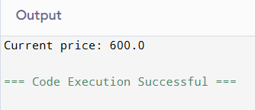

Task-03:
class Programming {
public String language;
//Default Constructor:
public Programming(){
language = "JAVA";
}
//Parameterized Constructor:
public Programming(String x){
language = x;
}
//Method:
void print(){
System.out.println("Language: " + language);
}
}
class task3 {
public static void main(String[] args){
Programming p1 = new Programming();
p1.print();
Programming p2 = new Programming("C");
p2.print();
}
}

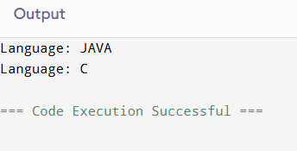

Task-04:
class Holiday {
public String name;
public int day;
public String month;
//Regular Constructor:
public Holiday(String name, int day, String month){
this.name = name;
this.day = day;
this.month = month;
}
//Copy Constructor (4(b)):
public Holiday(Holiday other){
this.name = other.name;
this.day = other.day;
this.month = other.month;
}
//Method:
public boolean inSameMonth(Holiday other){
return this.month.equalsIgnoreCase(other.month);
}
}
class task4 {
public static void main(String[] args){
Holiday h1 = new Holiday("Independence Day", 14, "August");
//Creating other holiday to check if month are equal using method
Holiday h2 = new Holiday("Defense Day", 6, "September");
if(h1.inSameMonth(h2)){
System.out.println("Both holidays occur in the same month!");
}
else{
System.out.println("Both holidays does not occur in the same month!");
}
// 4(b) Demonstrating the copy constructor
Holiday h3 = new Holiday(h1);
//Printing both original and copy to verify:
System.out.println("Object 1 using regular constructor: ");
System.out.println("Name: " + h1.name);
System.out.println("Day: " + h1.day);
System.out.println("Month: " + h1.month);
System.out.println("Object 3 using copy constructor: ");
System.out.println("Name: " + h3.name);
System.out.println("Day: " + h3.day);
System.out.println("Month: " + h3.month);
}
}
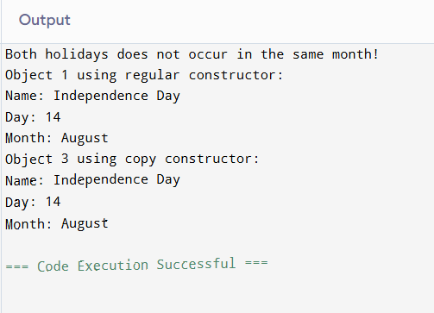
\

Task-05:
class Laptop {
private String brand;
private String model;
private double price;
private int stock;
//Default constructor:
public Laptop(){
brand = "";
model = "";
price = 0.0;
stock = 0;
}
//Parameterized constructor:
public Laptop(String brand, String model, double price, int stock){
this.brand = brand;
this.model = model;
this.price = price;
this.stock = stock;
}
//Copy constructor:
public Laptop(Laptop obj){
this.brand = obj.brand;
this.model = obj.model;
this.price = obj.price;
this.stock = obj.stock;
}
//Setter and getter methods:
public void setBrand(String brand){
this.brand = brand;
}
public String getBrand(){
return brand;
}
public void setModel(String model){
this.model = model;
}
public String getModel(){
return model;
}
public void setPrice(double price){
this.price = price;
}
public double getPrice(){
return price;
}
public void setStock(int stock){
this.stock = stock;
}
public int getStock(){
return stock;
}
//Destructor simulation:
public void finalize(){
System.out.println("Laptop object is being removed: " + brand + " " + model);
}
//Helper method to display laptop details
public void displayInfo(){
System.out.println("Brand: " + brand);
System.out.println("Model: " + model);
System.out.println("Price: PKR" + price);
System.out.println("Stock: " + stock);
System.out.println("------------------------");
}
}
class task5 {
public static void main(String[] args){
// Create laptop using default constructor
Laptop l1 = new Laptop();
System.out.println("Laptop 1 (Default Constructor - before setting values):");
l1.displayInfo();
// Set values using setters
l1.setBrand("Dell");
l1.setModel("Latitude");
l1.setPrice(26000);
l1.setStock(2);
System.out.println("Laptop 1 (After setting values):");
l1.displayInfo();
// Create laptop using parameterized constructor
Laptop l2 = new Laptop("HP", "Pavilion", 35000, 5);
System.out.println("Laptop 2 (Parameterized Constructor):");
l2.displayInfo();
// Create laptop using copy constructor (copy of l1)
Laptop l3 = new Laptop(l1);
System.out.println("Laptop 3 (Copy Constructor - copy of Laptop 1):");
l3.displayInfo();
// Demonstrate that copy is independent
l3.setPrice(28000);
l3.setStock(3);
System.out.println("Laptop 3 (After modifying copy):");
l3.displayInfo();
System.out.println("Laptop 1 (Original unchanged):");
l1.displayInfo();
// Demonstrate destructor simulation
System.out.println("Calling finalize manually (simulating destructor):");
l2.finalize();
System.out.println("Setting object to null and calling gc():");
l2 = null;
System.gc();
}
}

Output:
Laptop 1 (Default Constructor - before setting values):
Brand:
Model:
Price: PKR0.0
Stock: 0
------------------------
Laptop 1 (After setting values):
Brand: Dell
Model: Latitude
Price: PKR26000.0
Stock: 2
------------------------
Laptop 2 (Parameterized Constructor):
Brand: HP
Model: Pavilion
Price: PKR35000.0
Stock: 5
------------------------
Laptop 3 (Copy Constructor - copy of Laptop 1):
Brand: Dell
Model: Latitude
Price: PKR26000.0
Stock: 2
------------------------
Laptop 3 (After modifying copy):
Brand: Dell
Model: Latitude
Price: PKR28000.0
Stock: 3
------------------------
Laptop 1 (Original unchanged):
Brand: Dell
Model: Latitude
Price: PKR26000.0
Stock: 2
------------------------
Calling finalize manually (simulating destructor):
Laptop object is being removed: HP Pavilion
Setting object to null and calling gc():
Laptop object is being removed: HP Pavilion

Task-06:
class Book {
private String title;
private String author;
private double price;
//Constructor:
public Book(String title, String author, double price){
this.title = title;
this.author = author;
this.price = price;
}
//Setter:
public void setTitle(String title){
if(title!=null && !title.trim().isEmpty()){
this.title = title;
}
else{
System.out.println("Title cannot be empty!");
}
}
public void setAuthor(String author){
if(author!=null && !author.trim().isEmpty()){
this.author = author;
}
else{
System.out.println("Author cannot be empty!");
}
}
public void setPrice(double price){
if(price > 0){
this.price = price;
}
else{
this.price = 0.0;
System.out.println("Price cannot be negative. Set to 0.0");
}
}
//Getter:
public String getTitle(){
return title;
}
public String getAuthor(){
return author;
}
public double getPrice(){
return price;
}
}
class task6 {
public static void main(String[] args){
Book b1 = new Book("The Art of War", "Sun Tzu", 1200);
//for example:
b1.setPrice(600);
System.out.println("Current price: " + b1.getPrice());
}
}

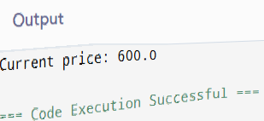

Task-07:
class Employee {
private int empID;
private String name;
private double basicSalary;
private int daysWorked;
//Default Constructor:
public Employee(){
empID = 0;
name = "";
basicSalary = 0.0;
daysWorked = 0;
}
//Parameterized Constructor:
public Employee(int empID, String name, double basicSalary, int daysWorked){
this.empID = empID;
this.name = name;
this.basicSalary = basicSalary;
this.daysWorked = daysWorked;
}
//Copy Constructor:
public Employee(Employee obj){
empID = obj.empID;
name = obj.name;
basicSalary = obj.basicSalary;
daysWorked = obj.daysWorked;
}
//Setter and Getters:
public void setEmpID(int empID){
this.empID = empID;
}
public int getEmpID(){
return empID;
}
public void setName(String name){
this.name = name;
}
public String getName(){
return name;
}
public void setBasicSalary(double basicSalary){
this.basicSalary = basicSalary;
}
public double getBasicSalary(){
return basicSalary;
}
public void setDaysWorked(int daysWorked){
this.daysWorked = daysWorked;
}
public int getDaysWorked(){
return daysWorked;
}
//Method:
public double calculateSalary(){
return (basicSalary / 30) * daysWorked;
}
public void displayInfo(){
System.out.println("Employee details: ");
System.out.println("ID: " + empID);
System.out.println("Name: " + name);
System.out.println("Basic salary: " + basicSalary);
System.out.println("Days worked: " + daysWorked);
}
//Destructor/Finalizer:
protected void finalize(){
System.out.println("Employee is being removed: " + empID + " " + name);
}
}
class task7 {
public static void main(String[] args){
Employee e1 = new Employee();
Employee e2 = new Employee(123, "Ali", 80000, 20);
Employee e3 = new Employee(e2);
//using some setter
e2.setName("John"); // This would "update details"
e2.setDaysWorked(25);
// Display all employee details with calculated salaries
System.out.println("\n=== Employee Details ===");
e1.displayInfo();
System.out.println("Calculated Salary: " + e1.calculateSalary() + "\n");
e2.displayInfo();
System.out.println("Calculated Salary: " + e2.calculateSalary() + "\n");
e3.displayInfo();
System.out.println("Calculated Salary: " + e3.calculateSalary());
//destructor/finalizer
e3.finalize();
e3 = null;
System.gc();
}
}
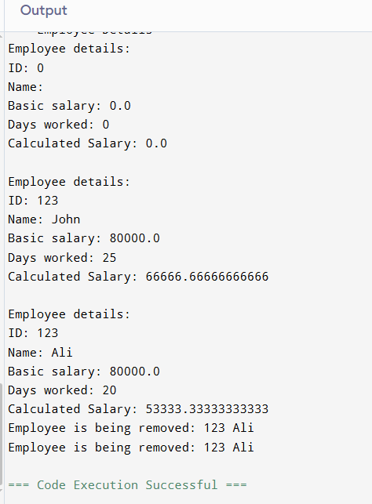

Task-08:
class GarbageCollection {
//Constructor:
public GarbageCollection(){
System.out.println("Object created");
}
//Finalize:
protected void finalize(){
System.out.println("Object deleted");
}
}
class task8 {
public static void main(String[] args){
System.out.println("=== Garbage Collection Demo ===\n");
//1. Null a reference:
GarbageCollection gc1 = new GarbageCollection();
gc1 = null;
System.gc();
//2. By assigning a reference to another object:
GarbageCollection gc2 = new GarbageCollection();
GarbageCollection gc3 = new GarbageCollection();
gc2 = gc3;
System.gc();
//3. By creating an anonymous object.
new GarbageCollection();
System.gc();
}
}

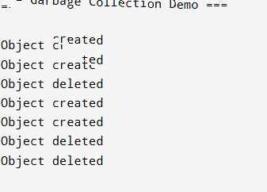
Output:

